LP Classifier: the algorithm
Step 1. Claim check
If the message only asks a question or describes the student's own situation, and gives no answer or reason → level = none. Stop.
Otherwise, continue.
Step 2. Score every concept
Split the answer into sentences. For each of the 173 Chapter-1 concepts, compute:
link score = cue points + meaning points + misconception points
- Cue points (pattern matching):
  - +2 for each code pattern of the concept found in the answer (at most 2 patterns)
  - +1 if a pattern appears only in the question's code
  - +1 if a cue appears in the part of the question being asked
  - +1 per key word found (a two-word key phrase counts 2), up to 3 points
- Meaning points (MiniLM): s = the highest cosine similarity between any answer sentence and the concept's description or facts. Points = 4 × (s − 0.40), or 0 if s ≤ 0.40.
- Misconception points (MiniLM): m = the highest cosine similarity between any answer sentence and the concept's known wrong beliefs. Points = 3 × (m − 0.50), or 0 if m ≤ 0.50.
Step 3. Keep concepts
Keep a concept if its score is ≥ 1.0 and ≥ half the best score, up to 3 concepts, highest first.
Add 1 extra concept: the one whose L1–L4 level descriptions are closest to the answer. It goes to the judge only and is not stored.
Step 4. Build the concept map
Place the kept concepts on the knowledge graph. Add their neighbours along prerequisite and parallel edges. Add a misconception only if the student holds it.
Step 5. Run the code
Run the question's code and compare every value the student states with the real output: correct or wrong.
Also run the program each known misconception would produce. If one reproduces the student's wrong values, the student holds that misconception.
Step 6. LLM judge (Claude)
Send Claude:
- the rubric (L0–L4 definitions and boundary rules)
- the question, the code and the run output
- the answer and the Step 5 results
- the L0–L4 descriptions of each kept concept and the extra concept, from the graph
Claude returns:
- per concept: a level, the way it was reached, and a quote
- overall: one level, the main concept, and a reason
Replies are saved, so the same answer always gets the same level.
Step 7. Final level
- No claim (Step 1) → none
- Otherwise, a wrong value or a reproduced misconception (Step 5) → L0
- Otherwise → Claude's overall level
- If Claude gave no overall level → the highest concept level
Output: the final level (none, L0–L4) and the concept map.

S001 · final L1 · reference L1
Question | What is the exact output, including line breaks? Explain how you got it.
Code | System.out.print("Welcome to Java. This is ");  System.out.println("A nice programming language ");  System.out.print("that I have to learn.");
Student answer | println adds a newline after the text and print does not.
Algorithmic workflow
Step | What happened
Step 1. Claim check | Claim: "println adds a newline after the text and print does not". No reasoning given.
Step 2. Score every concept | println = cues 2 + meaning 1.53 + misconception 1.15 = 4.68  standard_output = cues 1 + meaning 1.59 + misconception 1.15 = 3.74  print = cues 2 + meaning 1.17 + misconception 0.22 = 3.40  Meaning of println: MiniLM finds the answer 0.782 similar to its description → 4 × (0.782 − 0.40) = 1.53.
Step 3. Keep concepts | Cut-off 2.34 (half of 4.68). Kept: println, standard_output, print.
Step 4. Concept map | 3 kept + 7 neighbours, 14 links. Misconceptions held: PrintEqualsPrintln, PrintNewLineFirst, PrintEqualsPrintln.
Step 5. Run the code | No value to check.
Step 6. LLM judge | Claude gives println L1; standard_output L1; print L1; overall L1.
Step 7. Final level | Path: judge's overall level. Final L1 (reference L1).
Matching check: Correct. println, print and standard_output are exactly what the answer talks about.
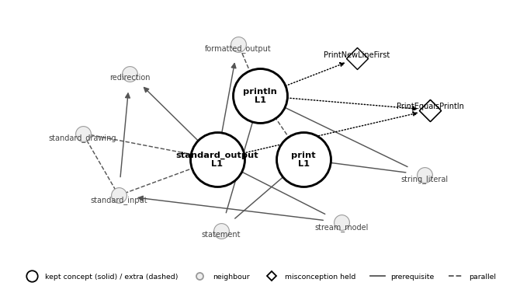

S005 · final L4 · reference L4
Question | What is the output? Explain. (b) What if i started at 61? (whole question; no part named)
Code | int i = 81;  do {  if (i % 2 == 1 && i != 73) {  System.out.printf("%d ", i);  }  i--;  } while (i >= 70);
Student answer | With a while loop the output is the same here, because 81 >= 70 is true at the start; it would only differ if i started below 70.
Algorithmic workflow
Step | What happened
Step 1. Claim check | Claim: "with a while loop the output is the same here; it would only differ if i started below 70". Reasoning: "because 81 >= 70 is true at the start".
Step 2. Score every concept | while_loop = cues 4 + meaning 0.68 + misconception 0.16 = 4.83  Meaning of while_loop: MiniLM finds the answer 0.569 similar to its description → 4 × (0.569 − 0.40) = 0.68.
Step 3. Keep concepts | Cut-off 2.42 (half of 4.83). Kept: while_loop. Extra for the judge: boolean_expression.
Step 4. Concept map | 1 kept + 10 neighbours, 11 links. Misconceptions held: none.
Step 5. Run the code | No value to check.
Step 6. LLM judge | Claude gives while_loop L4; boolean_expression L2; overall L4.
Step 7. Final level | Path: judge's overall level. Final L4 (reference L4).
Matching check: Main point missed. while_loop is right, but the answer compares a while loop with the do-while in the code; do_while_loop ("body first, test after") was not linked.
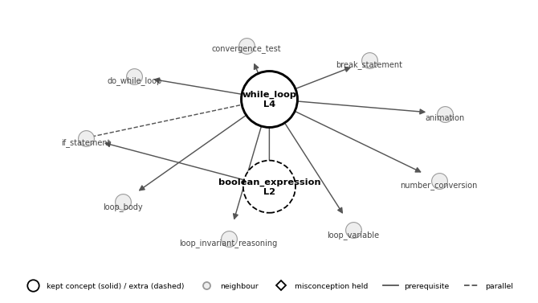

S007 · final L2 · reference L0
Question | Give the exact output, including spacing and empty lines. Explain.
Code | for (int i = 3; i >= 0; i--) {  for (int j = i; j > 0; j--) {  System.out.printf("%d ", j);  }  System.out.println();  }
Student answer | 3 2 1 / 2 1 / 1" (no empty line at the end), "because the loop stops at 1.
Algorithmic workflow
Step | What happened
Step 1. Claim check | Claim: "3 2 1 / 2 1 / 1 (no empty line at the end)". Reasoning: "because the loop stops at 1".
Step 2. Score every concept | string_literal = cues 2 = 2.00  expression = cues 2 = 2.00  arithmetic_operators = cues 2 = 2.00  Meaning of string_literal: MiniLM similarity only 0.241 (below 0.40) → 0 meaning points.
Step 3. Keep concepts | Cut-off 1.00 (half of 2.00). Kept: string_literal, expression, arithmetic_operators.
Step 4. Concept map | 3 kept + 10 neighbours, 12 links. Misconceptions held: none.
Step 5. Run the code | No value to check.
Step 6. LLM judge | Claude gives string_literal L2; expression no level; arithmetic_operators no level; overall L2.
Step 7. Final level | Path: judge's overall level. Final L2 (reference L0).
Matching check: Wrong. string_literal, expression and arithmetic_operators were kept on symbols alone (a quote mark, digits, minus; meaning below 0.40). The answer is about nested for loops and println.
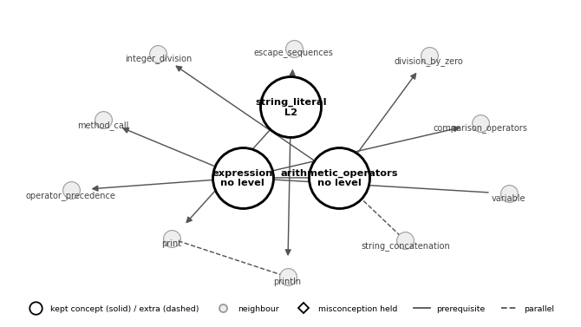

S008 · final L2 · reference L2
Question | What is the output? Trace i, num1 and num2. (b) Rewrite it with a for loop. (whole question; no part named)
Code | int num = 8, num1 = num + 1, num2 = num1 + 3;  int i = num;  do {  if (i != num1 && i != num2) {  System.out.printf("%d, ", i);  } else {  num2--;  }  i++;  } while (i < 14);
Student answer | num1 is 9 and num2 starts at 12. At i = 9 num2 drops to 11; at i = 11 it drops to 10. So it prints 8, 10, 12, 13,
Algorithmic workflow
Step | What happened
Step 1. Claim check | Claim: "it prints 8, 10, 12, 13,". Reasoning: "num1 is 9 and num2 starts at 12; at i = 9 num2 drops to 11; at i = 11 it drops to 10".
Step 2. Score every concept | assignment = cues 2 + meaning 0.12 = 2.12  increment_operators = cues 1 + meaning 0.38 + misconception 0.13 = 1.50  formatted_output = cues 1 + meaning 0.33 = 1.33  Meaning of assignment: MiniLM finds the answer 0.430 similar to its description → 4 × (0.430 − 0.40) = 0.12.
Step 3. Keep concepts | Cut-off 1.06 (half of 2.12). Kept: assignment, increment_operators, formatted_output.
Step 4. Concept map | 3 kept + 12 neighbours, 14 links. Misconceptions held: none.
Step 5. Run the code | I = 9: correct; i = 11: correct; num1 = 9 (final): correct; prints 8 10 12 13: correct.
Step 6. LLM judge | Claude gives assignment L2; increment_operators L2; formatted_output L2; overall L2.
Step 7. Final level | Path: judge's overall level. Final L2 (reference L2).
Matching check: Correct. increment_operators (num2 drops), assignment (values of num1, num2) and formatted_output (the printed list) cover the trace. do_while_loop would also fit.
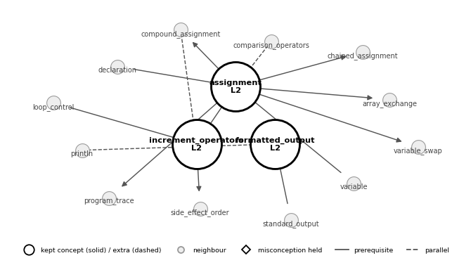

S009 · final L3 · reference L4
Question | Assign 7.9 to the next-to-last position without hard-coding the index.
Code | (writing task) double array sensorReadings already exists
Student answer | sensorReadings[sensorReadings.length - 2] = 7.9; — the last index is length - 1, so next-to-last is length - 2.
Algorithmic workflow
Step | What happened
Step 1. Claim check | Claim: "sensorReadings[sensorReadings.length - 2] = 7.9;". Reasoning: "the last index is length - 1, so next-to-last is length - 2".
Step 2. Score every concept | double = cues 4 = 4.00  length_field = cues 3 + meaning 0.57 = 3.57  expression = cues 3 + meaning 0.18 = 3.18  Meaning of double: MiniLM similarity only 0.391 (below 0.40) → 0 meaning points.
Step 3. Keep concepts | Cut-off 2.00 (half of 4.00). Kept: double, length_field, expression. Extra for the judge: array_bounds.
Step 4. Concept map | 3 kept + 13 neighbours, 21 links. Misconceptions held: none.
Step 5. Run the code | No value to check.
Step 6. LLM judge | Claude gives double L1; length_field L3; expression L1; array_bounds L3; overall L3.
Step 7. Final level | Path: judge's overall level. Final L3 (reference L4).
Matching check: Correct. length_field ("length - 2") and array_bounds as the extra ("last index is length - 1") cover the reasoning; double and expression are minor but present in the answer.
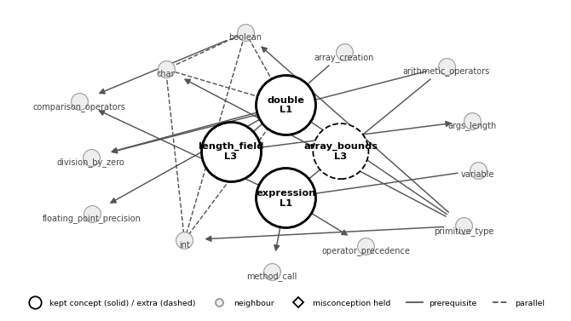

S010 · final L2 · reference L0
Question | Make an exact copy of data2 (no System.arraycopy).
Code | (writing task) int array data2 already exists
Student answer | for (int i = 0; i <= data2.length; i++) copy[i] = data2[i];
Algorithmic workflow
Step | What happened
Step 1. Claim check | Claim: "for (int i = 0; i <= data2.length; i++) copy[i] = data2[i];". No reasoning given.
Step 2. Score every concept | int = cues 4 + meaning 0.21 = 4.21  length_field = cues 3 + meaning 0.88 = 3.88  for_loop = cues 2 + meaning 0.94 + misconception 0.65 = 3.60  Meaning of int: MiniLM finds the answer 0.452 similar to its description → 4 × (0.452 − 0.40) = 0.21.
Step 3. Keep concepts | Cut-off 2.10 (half of 4.21). Kept: int, length_field, for_loop. Extra for the judge: array_copy.
Step 4. Concept map | 3 kept + 17 neighbours, 23 links. Misconceptions held: none.
Step 5. Run the code | No value to check.
Step 6. LLM judge | Claude gives int no level; length_field L0; for_loop L2; array_copy L2; overall L2.
Step 7. Final level | Path: judge's overall level. Final L2 (reference L0).
Matching check: Correct, plus noise. for_loop and length_field are right, and the <= bound was caught as a length_field misconception; int comes only from "int i"; array_copy is only the unstored extra.
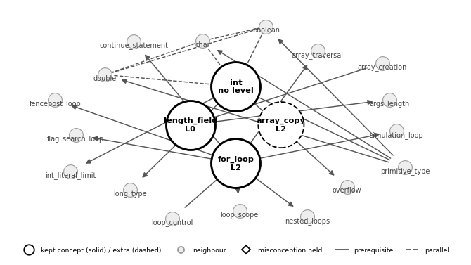

S012 · final none · reference none
Question | Show three different statements that add 1 to count and store the result in count.
Code | (writing task) int variable count already exists
Student answer | Is count++ the same as count += 1?
Algorithmic workflow
Step | What happened
Step 1. Claim check | Only a question ("Is count++ the same as count += 1?"): no claim.
Steps 2–6 | Skipped: no matching, no map, no judge.
Step 7. Final level | Path: no claim → none. Final none (reference none).
Matching check: Correct. A question with no claim, so no concepts.

S015 · final L2 · reference L0
Question | Declare a variable named singleLetter that holds one letter, with initial value Q, following Java convention.
Code | (writing task)
Student answer | char SingleLetter = 'Q';
Algorithmic workflow
Step | What happened
Step 1. Claim check | Claim: "char SingleLetter = 'Q';". No reasoning given.
Step 2. Score every concept | char = cues 5 + meaning 0.71 + misconception 0.07 = 5.78  Meaning of char: MiniLM finds the answer 0.578 similar to its description → 4 × (0.578 − 0.40) = 0.71.
Step 3. Keep concepts | Cut-off 2.89 (half of 5.78). Kept: char.
Step 4. Concept map | 1 kept + 6 neighbours, 12 links. Misconceptions held: none.
Step 5. Run the code | No value to check.
Step 6. LLM judge | Claude gives char L2; overall L2.
Step 7. Final level | Path: judge's overall level. Final L2 (reference L0).
Matching check: Main point missed. char is right, but the question and the mistake (SingleLetter) are about naming_convention, which was not linked.
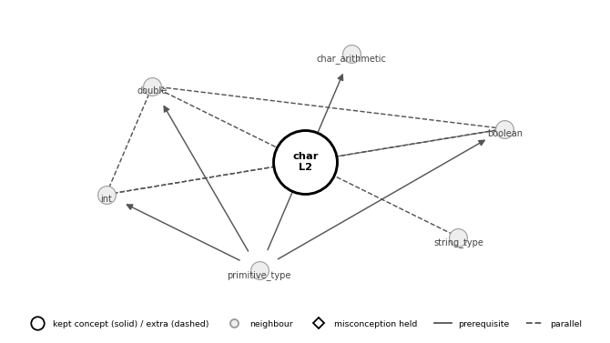

S016 · final L0 · reference L0
Question | What is the exact output? Explain how num4 is computed.
Code | int num1 = 9, num2 = 5;  double num3 = 26.3;  double num4 = (num1 % num2) + num3;  System.out.println("Result is ");  System.out.println("num4 = " + num4);
Student answer | num4 = 30.3, because 9 % 5 means 9 minus 5, which is 4.
Algorithmic workflow
Step | What happened
Step 1. Claim check | Claim: "num4 = 30.3". Reasoning: "because 9 % 5 means 9 minus 5, which is 4".
Step 2. Score every concept | arithmetic_operators = cues 4 + meaning 0.28 = 4.28  double = cues 4 + meaning 0.04 = 4.04  remainder_operator = cues 3 + meaning 0.50 + misconception 0.14 = 3.64  Meaning of arithmetic_operators: MiniLM finds the answer 0.470 similar to its description → 4 × (0.470 − 0.40) = 0.28.
Step 3. Keep concepts | Cut-off 2.14 (half of 4.28). Kept: arithmetic_operators, double, remainder_operator.
Step 4. Concept map | 3 kept + 9 neighbours, 17 links. Misconceptions held: none.
Step 5. Run the code | Num4 = 30.3: correct.
Step 6. LLM judge | Claude gives arithmetic_operators L0; double L1; remainder_operator L0; overall L0.
Step 7. Final level | Path: judge's overall level. Final L0 (reference L0).
Matching check: Correct. remainder_operator, arithmetic_operators and double are what the answer and its wrong rule are about.
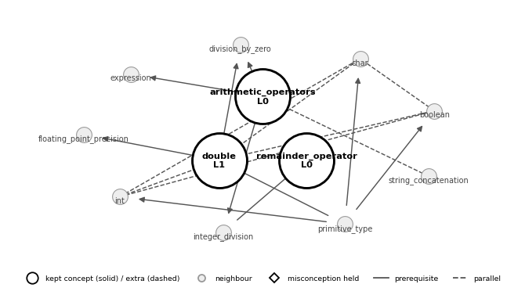

S021 · final L2 · reference L2
Question | What is printed when x = 17? Explain.
Code | System.out.print("A");  if (x % 2 == 0) {  System.out.print("B");  if (x % 5 == 2) { System.out.print("C"); } else { System.out.print("D"); }  } else {  if (x % 5 == 2) { System.out.print("E"); } else { System.out.print("F"); }  System.out.print("G");  }
Student answer | So first Java looks at the code and the first thing it does is print A, which always happens no matter what x is, and then it checks whether x is even, and 17 is not even because 17 divided by 2 leaves 1, so it skips the whole first part with B, C and D, and goes to the else part, where it checks 17 % 5, which is 2, so it prints E, and then after that inner if-else it prints G, so overall I think the answer would be AEG, which makes sense because…
Algorithmic workflow
Step | What happened
Step 1. Claim check | Claim: "the answer would be AEG". Reasoning: "prints A always; 17 is not even (17 / 2 leaves 1) so it skips B, C, D; goes to else; 17 % 5 is 2 so it prints E; after the inner if-else it prints G".
Step 2. Score every concept | if_else_statement = cues 4 = 4.00  remainder_operator = cues 2 + meaning 0.70 = 2.70  arithmetic_operators = cues 2 + meaning 0.34 = 2.33  Meaning of if_else_statement: MiniLM similarity only 0.373 (below 0.40) → 0 meaning points.
Step 3. Keep concepts | Cut-off 2.00 (half of 4.00). Kept: if_else_statement, remainder_operator, arithmetic_operators.
Step 4. Concept map | 3 kept + 8 neighbours, 9 links. Misconceptions held: none.
Step 5. Run the code | No value to check.
Step 6. LLM judge | Claude gives if_else_statement L2; remainder_operator L2; arithmetic_operators L2; overall L2.
Step 7. Final level | Path: judge's overall level. Final L2 (reference L2).
Matching check: Correct. if_else_statement and remainder_operator are right; nested_conditionals would be more specific.
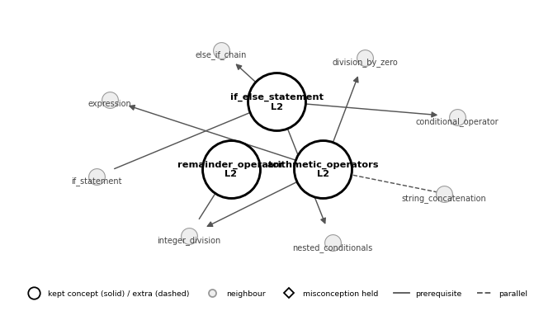

S023 · final L3 · reference L3
Question | If value is 2, what is result after the switch? Explain.
Code | switch (value) {  case 1: result = 10;  case 2:  case 3: result = 20;  case 4: result = 40;  default: result = 50;  }
Student answer | the swich no have break so it go down all the case and result become 50
Algorithmic workflow
Step | What happened
Step 1. Claim check | Claim: "result become 50". Reasoning: "the swich no have break so it go down all the case".
Step 2. Score every concept | switch_statement = cues 2 + meaning 0.18 = 2.18  statement = cues 2 = 2.00  Meaning of switch_statement: MiniLM finds the answer 0.444 similar to its description → 4 × (0.444 − 0.40) = 0.18.
Step 3. Keep concepts | Cut-off 1.09 (half of 2.18). Kept: switch_statement, statement. Extra for the judge: assignment, break_statement.
Step 4. Concept map | 1 kept + 2 neighbours, 2 links. Misconceptions held: none.
Step 5. Run the code | No value to check.
Step 6. LLM judge | Claude gives switch_statement L3; statement no level; assignment L1; break_statement L3; overall L3.
Step 7. Final level | Path: judge's overall level. Final L3 (reference L3).
Matching check: Correct, plus noise. switch_statement is right and break_statement reached the judge as the extra; statement is noise from ";".
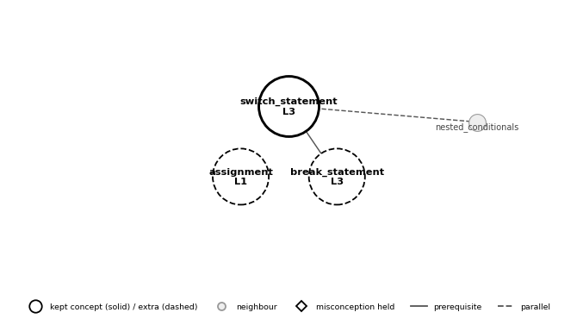

S026 · final none · reference L1
Question | Explain in plain English what these three lines do.
Code | int t = a;  a = b;  b = t;
Student answer | a becomes b and b becomes a.
Algorithmic workflow
Step | What happened
Step 1. Claim check | Claim: "a becomes b and b becomes a". No reasoning given.
Step 2. Score every concept | assignment = cues 1 + meaning 1.00 + misconception 0.63 = 2.63  array_aliasing = cues 1 + meaning 0.56 + misconception 0.31 = 1.87  variable = cues 1 + meaning 0.75 = 1.75  Meaning of assignment: MiniLM finds the answer 0.651 similar to its description → 4 × (0.651 − 0.40) = 1.00.
Step 3. Keep concepts | Cut-off 1.31 (half of 2.63). Kept: assignment, array_aliasing, variable.
Step 4. Concept map | Nothing stored: no kept concept got a level.
Step 5. Run the code | No value to check.
Step 6. LLM judge | Claude gives assignment no level; array_aliasing no level; variable no level; no overall level.
Step 7. Final level | Path: no overall level → highest concept level. Final none (reference L1).
Matching check: Main point missed. assignment and variable are right; array_aliasing is wrong (there are no arrays); variable_swap was not linked.

S047 · final L4 · reference L4
Question | What is printed, exactly (count the spaces)? Explain each format specifier.
Code | double price = 3.14159;  System.out.printf("%6.2f", price);  System.out.printf("|%d items%n", 4);
Student answer | With %.3f it would print 3.142 and no spaces. price itself is still 3.14159; only the printed digits change.
Algorithmic workflow
Step | What happened
Step 1. Claim check | Claim: "with %.3f it would print 3.142 and no spaces". Reasoning: "price itself is still 3.14159; only the printed digits change".
Step 2. Score every concept | formatted_output = cues 4 + meaning 1.02 + misconception 0.55 = 5.56  double = cues 3 + meaning 0.17 = 3.17  Meaning of formatted_output: MiniLM finds the answer 0.655 similar to its description → 4 × (0.655 − 0.40) = 1.02.
Step 3. Keep concepts | Cut-off 2.78 (half of 5.56). Kept: formatted_output, double.
Step 4. Concept map | 2 kept + 8 neighbours, 14 links. Misconceptions held: FieldWidthIsIntegerDigits.
Step 5. Run the code | No value to check.
Step 6. LLM judge | Claude gives formatted_output L4; double L1; overall L4.
Step 7. Final level | Path: judge's overall level. Final L4 (reference L4).
Matching check: Correct. formatted_output and double are what the answer is about.
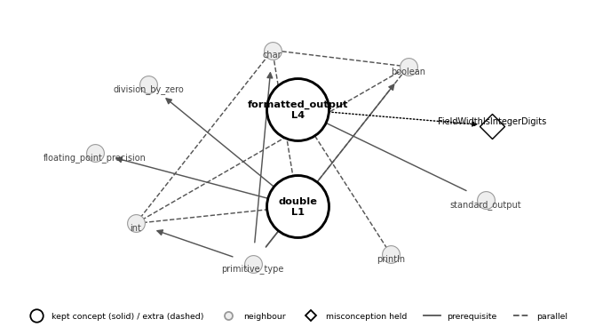

S052 · final L2 · reference L3
Question | What appears in the terminal after each command? What does args[] contain when Average runs?
Code | % java RandomSeq 5 > data.txt  % java Average < data.txt  % java RandomSeq 5 | java Average  (RandomSeq N prints N random numbers; Average reads numbers from standard input and prints their average)
Student answer | 1: nothing, the numbers go into data.txt. 2: the average. 3: an average of 5 new numbers, no file. args is empty.
Algorithmic workflow
Step | What happened
Step 1. Claim check | Claim: "1: nothing; 2: the average; 3: an average of 5 new numbers, no file; args is empty". Reasoning: "the numbers go into data.txt (command 1)".
Step 2. Score every concept | command_line_args = cues 2 + meaning 0.57 + misconception 0.63 = 3.20  redirection = cues 2 + meaning 0.68 + misconception 0.03 = 2.71  piping = cues 2 + meaning 0.28 + misconception 0.03 = 2.31  Meaning of command_line_args: MiniLM finds the answer 0.543 similar to its description → 4 × (0.543 − 0.40) = 0.57.
Step 3. Keep concepts | Cut-off 1.60 (half of 3.20). Kept: command_line_args, redirection, piping.
Step 4. Concept map | 3 kept + 8 neighbours, 11 links. Misconceptions held: none.
Step 5. Run the code | No value to check.
Step 6. LLM judge | Claude gives command_line_args L1; redirection L2; piping L2; overall L2.
Step 7. Final level | Path: judge's overall level. Final L2 (reference L3).
Matching check: Correct. redirection, piping and command_line_args are what the answer is about.
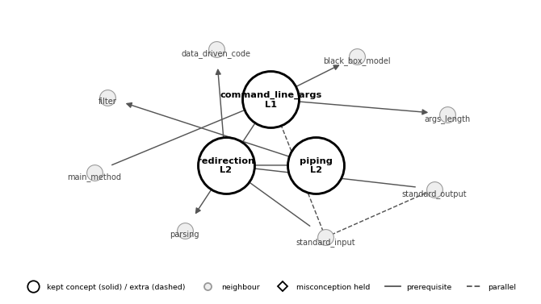

S057 · final L3 · reference L3
Question | What does p hold after the loop? Is it a probability row? Fix it if needed.
Code | int[] counts = {0, 0, 2, 2, 1};  int outDegree = 5;  double[] p = new double[5];  for (int j = 0; j < 5; j++) {  p[j] = counts[j] / outDegree;  }
Student answer | All zeros, because int / int is integer division. Cast: (double) counts[j] / outDegree gives 0, 0, 0.4, 0.4, 0.2, which sums to 1.
Algorithmic workflow
Step | What happened
Step 1. Claim check | Claim: "all zeros". Reasoning: "int / int is integer division; cast: (double) counts[j] / outDegree gives 0, 0, 0.4, 0.4, 0.2, which sums to 1".
Step 2. Score every concept | int = cues 4 + meaning 0.78 = 4.78  explicit_cast = cues 3 + meaning 0.86 + misconception 0.15 = 4.01  type_conversion = cues 3 + meaning 0.40 = 3.40  Meaning of int: MiniLM finds the answer 0.595 similar to its description → 4 × (0.595 − 0.40) = 0.78.
Step 3. Keep concepts | Cut-off 2.39 (half of 4.78). Kept: int, explicit_cast, type_conversion. Extra for the judge: normalization.
Step 4. Concept map | 3 kept + 12 neighbours, 21 links. Misconceptions held: none.
Step 5. Run the code | No value to check.
Step 6. LLM judge | Claude gives int L2; explicit_cast L3; type_conversion L3; normalization L3; overall L3.
Step 7. Final level | Path: judge's overall level. Final L3 (reference L3).
Matching check: Correct. int ("/ discards the fraction") and explicit_cast cover the cause and the fix; normalization (sums to 1) is the extra.
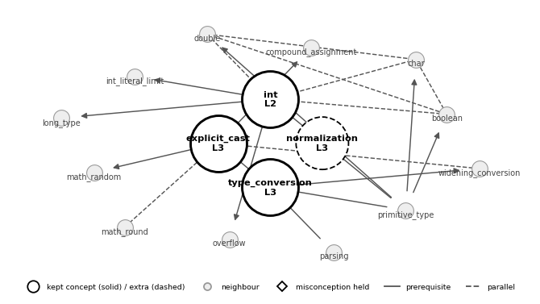

S068 · final L0 · reference L0
Question | Are these the page ranks? Would starting at page 3 change them?
Code | RandomSurfer was run for 100 moves starting at page 0 and printed:  0.31000 0.25000 0.14000 0.24000 0.06000
Student answer | They are estimates. But starting at page 3 would change the ranks.
Algorithmic workflow
Step | What happened
Step 1. Claim check | Claim: "They are estimates. But starting at page 3 would change the ranks". No reasoning given.
Step 2. Score every concept | frequency_counting = cues 1 + meaning 0.31 + misconception 0.41 = 1.71  power_method = cues 1 + meaning 0.28 + misconception 0.23 = 1.51  run = cues 1 = 1.00  Meaning of frequency_counting: MiniLM finds the answer 0.477 similar to its description → 4 × (0.477 − 0.40) = 0.31.
Step 3. Keep concepts | Cut-off 1.00 (the minimum 1.0). Kept: frequency_counting, power_method, run. Extra for the judge: markov_chain.
Step 4. Concept map | 2 kept + 5 neighbours, 7 links. Misconceptions held: none.
Step 5. Run the code | No value to check.
Step 6. LLM judge | Claude gives frequency_counting L1; power_method no level; run no level; markov_chain L0; overall L0.
Step 7. Final level | Path: judge's overall level. Final L0 (reference L0).
Matching check: Correct, plus noise. frequency_counting and power_method are right and markov_chain is the extra; run (Java runs main) is the wrong sense of "run for 100 moves".
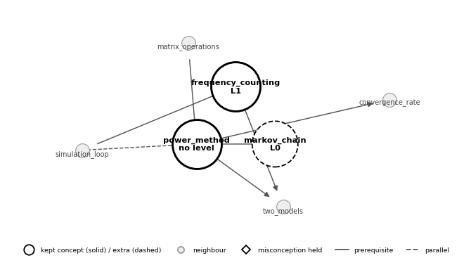

S073 · final L0 · reference L2
Question | If value is 2, what is result after the switch? Explain.
Code | switch (value) {  case 1: result = 10;  case 2:  case 3: result = 20;  case 4: result = 40;  default: result = 50;  }
Student answer | Turn 1: "result is 20."  Probe: "If value is 1, what is result?"  Turn 2: "10. Oh wait, then 20, 40, 50… so for 2 it is 50 too."
Algorithmic workflow
Step | What happened
Step 1. Claim check | Claim: "Turn 1: result is 20". Reasoning: "Turn 2 (after the probe): 10. Oh wait, then 20, 40, 50… so for 2 it is 50 too".
Step 2. Score every concept | conditional_operator = cues 3 + meaning 0.24 = 3.24  Meaning of conditional_operator: MiniLM finds the answer 0.461 similar to its description → 4 × (0.461 − 0.40) = 0.24.
Step 3. Keep concepts | Cut-off 1.62 (half of 3.24). Kept: conditional_operator. Extra for the judge: assignment, statement.
Step 4. Concept map | 1 kept + 1 neighbour, 1 link. Misconceptions held: none.
Step 5. Run the code | Result = 20 (taken as final): wrong.
Step 6. LLM judge | Claude gives conditional_operator no level; assignment L2; statement L2; overall L2.
Step 7. Final level | Path: wrong value → L0 (overrides the judge). Final L0 (reference L2).
Matching check: Wrong. conditional_operator was linked from the "?" in the tutor's question; the answer traces a switch (switch_statement, break_statement).
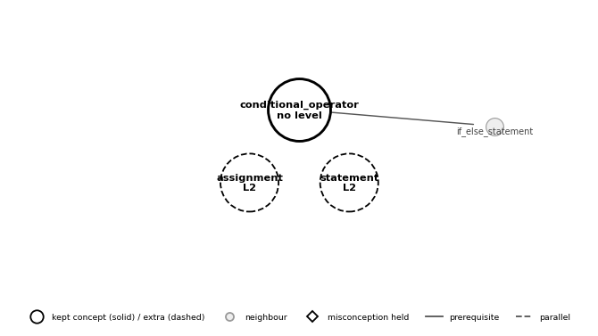

S080 · final L3 · reference L3
Question | What goes wrong, and in what order will the student meet each problem? Which line(s) never run?
Code | // saved as Hello.java, run as: java Greeting Ann  public class Greeting {  public static void main(String[] args) {  System.out.println("Hi, " + args[1])  // System.out.println("Bye");  }  }
Student answer | Two compile errors first: the class must be in Greeting.java and the ; is missing. After that it compiles, but args[1] crashes at run time because Ann is args[0]. The comment never runs.
Algorithmic workflow
Step | What happened
Step 1. Claim check | Claim: "two compile errors first, then args[1] crashes at run time; the comment never runs". Reasoning: "the class must be in Greeting.java and the ; is missing; after that it compiles, but args[1] crashes because Ann is args[0]".
Step 2. Score every concept | command_line_args = cues 3 + meaning 0.75 + misconception 0.53 = 4.28  compile = cues 3 + meaning 0.63 + misconception 0.39 = 4.02  program_text = cues 3 + meaning 0.57 = 3.57  Meaning of command_line_args: MiniLM finds the answer 0.587 similar to its description → 4 × (0.587 − 0.40) = 0.75.
Step 3. Keep concepts | Cut-off 2.14 (half of 4.28). Kept: command_line_args, compile, program_text. Extra for the judge: comment.
Step 4. Concept map | 3 kept + 9 neighbours, 11 links. Misconceptions held: none.
Step 5. Run the code | No value to check.
Step 6. LLM judge | Claude gives command_line_args L3; compile L3; program_text L3; comment L2; overall L3.
Step 7. Final level | Path: judge's overall level. Final L3 (reference L3).
Matching check: Correct. compile, program_text and command_line_args are right; run_time_error would add the args[1] crash.
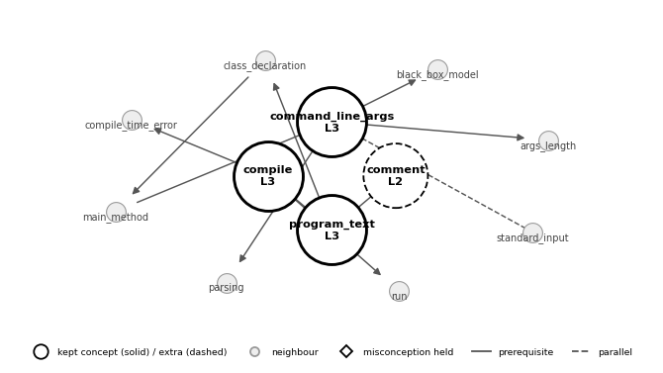

S134 · final L0 · reference L0
Question | Explain in plain English what these three lines do.
Code | int t = a;  a = b;  b = t;
Student answer | After t = a and a = b, a is b. Then b = t means b equals a, so both are b.
Algorithmic workflow
Step | What happened
Step 1. Claim check | Claim: "both are b". Reasoning: "after t = a and a = b, a is b; then b = t means b equals a".
Step 2. Score every concept | assignment = cues 2 + meaning 0.60 + misconception 0.53 = 3.13  array_aliasing = cues 1 + meaning 0.84 + misconception 0.70 = 2.54  Meaning of assignment: MiniLM finds the answer 0.549 similar to its description → 4 × (0.549 − 0.40) = 0.60.
Step 3. Keep concepts | Cut-off 1.56 (half of 3.13). Kept: assignment, array_aliasing. Extra for the judge: variable_swap.
Step 4. Concept map | 2 kept + 12 neighbours, 13 links. Misconceptions held: none.
Step 5. Run the code | No value to check.
Step 6. LLM judge | Claude gives assignment L0; array_aliasing no level; variable_swap L0; overall L0.
Step 7. Final level | Path: judge's overall level. Final L0 (reference L0).
Matching check: Main point missed. assignment is right; array_aliasing is wrong (no arrays); variable_swap is only the unstored extra.
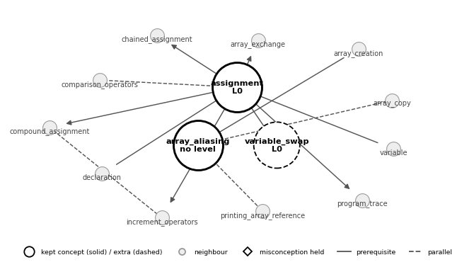

S137 · final L0 · reference L0
Question | What is the exact output, including line breaks? Explain how you got it.
Code | System.out.print("Welcome to Java. This is ");  System.out.println("A nice programming language ");  System.out.print("that I have to learn.");
Student answer | System.out.println("x is 5"); sets x to 5.
Algorithmic workflow
Step | What happened
Step 1. Claim check | Claim: "System.out.println("x is 5"); sets x to 5". No reasoning given.
Step 2. Score every concept | println = cues 3 + meaning 0.87 + misconception 0.38 = 4.26  method_call = cues 2 + meaning 1.02 = 3.02  standard_output = cues 2 + meaning 0.88 + misconception 0.06 = 2.94  Meaning of println: MiniLM finds the answer 0.618 similar to its description → 4 × (0.618 − 0.40) = 0.87.
Step 3. Keep concepts | Cut-off 2.13 (half of 4.26). Kept: println, method_call, standard_output.
Step 4. Concept map | 3 kept + 11 neighbours, 17 links. Misconceptions held: none.
Step 5. Run the code | X = 5: wrong (the code has no variable x).
Step 6. LLM judge | Claude gives println no level; method_call no level; standard_output L0; overall L0.
Step 7. Final level | Path: wrong value → L0 (overrides the judge). Final L0 (reference L0).
Matching check: Correct. println and standard_output are right for the misreading "println sets x".
